1. **Introduction**

**Purpose of the Document:**

The goal of this document is to provide you a thorough overview of the software project "Wandering in the Woods." It acts as a reference guide for project developers, stakeholders, and team members. To guarantee a common understanding of the software's scope and functionality, this paper covers its requirements, design, and technical specifications.

**Brief Overview of the Software:**

"Wandering in the Woods" is an engrossing grid-based adventure game set in an enigmatic forest. Players go on an exciting adventure with the goal of encouraging characters to meet each other within the forest. The game incorporates aspects of exploration, strategy, and chance to create an immersive and fun gaming experience. This article will go into the technical features, design, and user-related information of the software, allowing for a comprehensive understanding of its development and usage.

**2. Scope**

**Description of the Software's Boundaries:**

The scope of the software defines its boundaries and what is included or excluded in its functionality. It helps stakeholders understand the extent and limitations of the software.

**Inclusions:**

* Grid-Based Adventure Gameplay: The software includes a grid-based adventure game set in a mysterious forest, where players navigate characters to meet each other within the forest.
* Multiple Game Modes: It offers different game modes suitable for different age groups, including K-2, 3-5, and 6-8, each with adjusted complexity and objectives.
* Audio Integration: The software seamlessly integrates audio elements, such as background music and sound effects, to enhance the gaming experience.
* Game Statistics: Players can view game statistics, including the longest run, shortest run, and average run, to track their progress.

**3. Software Requirements Specifications (SRS)**

**Functional Requirements:**

Functional requirements define the specific functions and features that the software must provide to fulfil its intended purpose.

**Description of Key Functionalities:**

This section outlines the primary functionalities of the software.

* Player Movement: Players can navigate through the forest grid by moving their characters in four directions: up, down, left, and right.
* Meeting Mechanism: When two or more players occupy the same grid cell, they merge into a group.
* Game Modes: The game offers different modes suitable for different age groups, including K-2, 3-5, and 6-8, each with adjusted complexity and objectives.

**Use Case Diagram: "Wandering in the Woods" Game**

Use cases provide detailed scenarios of how users interact with the software to achieve specific tasks.

Use Case 1: Player Movement

* + Actors: Player
  + Description: Players use arrow keys or controls to move their character on the grid.
  + Precondition: The game is running, and the player's character is active.
  + Postcondition: The player's character occupies a new grid cell.

Use Case 2: Meeting Mechanism

* + Actors: Players
  + Description: Two or more players move their characters to the same grid cell, resulting in the formation of a group.
  + Precondition: Multiple players are active and in proximity on the grid.
  + Postcondition: A new group is formed with the merged players.

Use Case 3: Game Modes Selection

* + Actors: Player
  + Description: Players can choose from different game modes (K-2, 3-5, 6-8) at the start of the game.
  + Precondition: The game is launched, and the player is at the main menu.
  + Postcondition: The selected game mode is initiated with adjusted objectives.

Use Case 4: Display Game Statistics

* + Actors: Player
  + Description: Players can view game statistics, including the longest run, shortest run, and average run, to track their progress.
  + Precondition: The game is ongoing, and the player accesses the statistics menu.
  + Postcondition: Game statistics are displayed for the player's reference.

Use Case 5: Audio Integration

* + Actors: Player
  + Description: The game seamlessly integrates audio elements, such as background music and sound effects, enhancing the gaming experience.
  + Precondition: The game is running.
  + Postcondition: Audio elements are played as intended during gameplay.

**Non-Functional Requirements:**

Non-functional requirements address aspects of the software beyond specific functionalities. They include performance, security, and system-level requirements.

**Performance Requirements:**

Performance requirements specify how the software should perform under different conditions.

* Response Time: The software must respond to user inputs with minimal delay, targeting a response time of less than 100 milliseconds.
* Scalability: The software should accommodate up to 100 players simultaneously, ensuring smooth gameplay as the number of players increases.

**Security Requirements:**

Security requirements outline measures to protect user data and ensure authorized access.

* Data Encryption: User data, including game progress and statistics, should be securely encrypted using AES-256 encryption.
* Access Control: Access to sensitive game data and administrative functions should be restricted to authorized users using role-based access control (RBAC).

**Other System-Level Requirements:**

Other system-level requirements ensure compatibility and a seamless user experience.

* Platform Compatibility: The software should be compatible with common operating systems, including Windows 10, macOS Big Sur, and Ubuntu 20.04.
* Audio Integration: The software should seamlessly integrate audio elements (MP3 and WAV formats) to enhance the gaming experience.

These requirements provide a comprehensive view of what the software should do, how it should perform, and how it should protect user data and ensure a seamless user experience.  
  
**4. System Architecture**

**Overview of Software Architecture**

The software architecture section provides an overview of how the software is structured and how its components interact to deliver the desired functionality.

The "Wandering in the Woods" game follows a modular and scalable architecture, ensuring flexibility in accommodating various game modes and future enhancements. The primary architectural components include:

* User Interface (UI): This component handles the presentation layer of the game, including menus, game graphics, and user interactions. We utilize the Tkinter library for creating user-friendly menus and interfaces.
* Game Logic: The core of the game resides in this component. It manages player movement, collision detection, game modes, and the meeting mechanism. The game logic ensures smooth gameplay and adherence to the predefined rules.
* Audio Integration: This component is responsible for seamlessly integrating audio elements into the game. It manages background music, sound effects, and audio notifications, enhancing the overall gaming experience.
* Data Management: To maintain game statistics and progress, a data management component is integrated. It securely stores player data, statistics, and game configuration settings.

**Component Diagram (if applicable):**

A component diagram provides a visual representation of the software's high-level components and their relationships. Below is a textual representation of the component diagram:

**User Interface (UI):**

Subcomponents:

* + - Main Menu
    - In-Game Interface

Dependencies:

* + - Game Logic
    - Audio Integration

**Game Logic:**

Subcomponents:

* + - Player Movement
    - Meeting Mechanism
    - Game Modes

Dependencies:

* + - User Interface (UI)
    - Data Management
    - Audio Integration

**Audio Integration**

Subcomponents:

* + - Background Music
    - Sound Effects

Dependencies:

* + - User Interface (UI)
    - Game Logic

**Data Management**

Subcomponents:

* + - Player Data
    - Game Statistics

Dependencies:

* + - Game Logic

The component diagram depicts the primary software components and their relationships. Each component is critical to providing a flawless and interesting game experience. The modular architecture enables simple maintenance, upgrades, and the introduction of new features in future game iterations.

**5. Data Model**

**Description of Data Structures**

The data model section describes the data structures that are used to organize and store information within the software. Several data structures are used in the "Wandering in the Woods" game to improve gameplay and store important data.

**Grid Data Structure**

* Purpose: To represent the game grid, including the forest cells and player positions.
* Attributes: The grid data structure is typically a two-dimensional array or list, where each element represents a cell on the grid. Each cell may contain information about its occupancy (player, group, or empty).

**Player Data Structure**

* Purpose: To store information about individual players, such as their current position, game statistics, and unique identifiers.
* Attributes: Player data includes the player's x and y coordinates on the grid, their game mode.

**Game Statistics Data Structure**

* Purpose: To record and manage game statistics, including the longest run, shortest run, and average run.
* Attributes: Game statistics data structure stores records of past game runs, allowing for the calculation of the longest run, shortest run, and average run.

**Databases**

The "Wandering in the Woods" game does not require a traditional database system, as the data involved is relatively simple and can be managed within the application. Data is stored in memory during gameplay and is saved to local storage for persistence.

**Local Storage**

* Purpose: To persist player data and game statistics between game sessions.
* Implementation: Local storage is achieved using file I/O operations in Python. Player data and game statistics are saved in text or JSON format and loaded back into memory when the game starts.

**Data Encryption**

* Purpose: To ensure the security of user data, including game progress and statistics.
* Implementation: Data stored in local storage is encrypted using AES-256 encryption, providing an additional layer of protection against unauthorized access.

The data model is designed to efficiently manage game-related data and statistics while ensuring the security and privacy of user information. Data is structured logically to support gameplay and enable tracking of performance metrics.

**6. User Interface Design**

**Description of User Interface Elements**

The user interface (UI) design is crucial for creating an engaging and user-friendly gaming experience in "Wandering in the Woods." This section provides an overview of the key UI elements and their roles in the game.

**Main Menu**

* Purpose: The main menu serves as the entry point for players and provides options for selecting game modes and accessing game statistics.

**In-Game Interface**

* Purpose: The in-game interface displays the game grid, player characters, and relevant game information, such as the current game mode and statistics.

**Buttons**

* Purpose: Buttons are used throughout the UI to allow users to interact with the game, select game modes, and trigger specific actions (e.g., restarting the game).

**Images and Graphics**

* Purpose: High-quality images and graphics, including the forest background and player characters, enhance the visual appeal of the game.

**Audio Elements**

* Purpose: Background music, sound effects, and audio notifications contribute to the immersive gaming experience.

**7. Implementation Details**

**Technology Stack**

The choice of technology stack plays a critical role in the successful development of "Wandering in the Woods." This section outlines the technologies and tools used in the implementation of the game.

**Programming Language**

* Python: The core game logic is implemented in Python, providing a versatile and efficient platform for game development.

**Libraries and Frameworks**

* Pygame: Pygame is utilized for graphics rendering, event handling, and audio integration.
* Tkinter: Tkinter is used for creating the user interface elements, including the main menu.

**Coding Standards and Guidelines**

Maintaining a consistent and well-structured codebase is essential for readability, maintainability, and collaboration among developers. This section outlines the coding standards and guidelines followed during the implementation of "Wandering in the Woods."

**Code Structure**

* The codebase is organized into modular components, with separate modules for game logic, UI, audio, and data management.

**Naming Conventions**

* Descriptive and meaningful variable and function names are used to enhance code readability.

**Commenting and Documentation**

* Code is thoroughly commented to explain complex logic and provide context for future maintainers.

**Version Control**

* Git is employed for version control, allowing for collaborative development and tracking of code changes.

**Testing and Quality Assurance**

* Unit tests are conducted to ensure the correctness of critical game functions.

**Error Handling**

* Robust error handling is implemented to gracefully manage unexpected situations and provide clear error messages to users.

The implementation details section highlights the technologies and practices used to build the game and emphasizes the importance of maintaining code quality and consistency throughout the development process.

**User's Guide for "Wandering in the Woods" Game**

**Introduction**

Welcome to the game "Wandering in the Woods"! This user's guide is intended to assist you in getting started with the game and to provide you with all the information you need to enjoy your adventure in the strange forest.

**Brief Overview of the Game**

"Wandering in the Woods" is an interesting grid-based adventure game that transports you to a dense and mysterious woodland. Your mission is to explore the woodland and guide all the players to the same area. It's a game of exploration, strategy, and a dash of chance as you make your way through the woods. Prepare yourself for an immersive gaming experience!

**2. Installation**

Before you embark on your forest adventure, you'll need to install the game. Follow these step-by-step installation instructions to get started.

**Step-by-Step Installation Instructions**

Step 1: Check Prerequisites

Before you begin, ensure that you have the following prerequisites installed on your computer:

* Python: The game is developed in Python, so you'll need Python installed. You can download Python from the official website: [python.org](https://www.python.org/downloads/)
* Pygame: Pygame is the graphics and game interactions library. Pip, a Python package manager, can be used to install Pygame. Run the following command in your command prompt or terminal:

**pip install pygame**

**Step 2: Download the Game**

* Download the "Wandering in the Woods" game files from [Game Repository URL].

**Step 3: Extract the Files**

After the download is finished, extract the game files by your preferred location on your computer.

**Launching the Game**

**Step 4: Start the Game**

Follow these simple steps to start the game:

1. Go to the location where you extracted the game files.
2. Locate the main game file, which is normally named "main.py."
3. To start the game, double-click the "main.py" file. **Getting Started**

**Starting the Game**

To embark on your forest adventure, start the game by following these steps:

1. Confirm that you've successfully installed the game, as instructed in the Installation section.
2. Locate the folder where you extracted the game files.
3. Identify the main game file, typically labelled "main.py."
4. Launch the game by double-clicking on "main.py."

**Basic Navigation and Controls**

Once the game begins, find yourself in the heart of the dense forest. Here are the fundamental controls to help you navigate and enjoy your journey:

* Use the arrow keys on your keyboard to move your character in the corresponding directions (up, down, left, right).
* Access the in-game menu by pressing the designated menu key, typically "M." This menu allows you to pause the game, restart, or return to the main menu.
* Interact with certain in-game objects by using the designated interaction key, often "Spacebar."
* Manage the game's sound settings by pressing the sound key, usually "S," to toggle sound effects and background music on or off.

**Game Modes**

"Wandering in the Woods" features a variety of game types customized to different age groups, offering an engaging experience for all players. Each game option offers a distinct journey and level of difficulty. Here's a rundown of the available game modes:

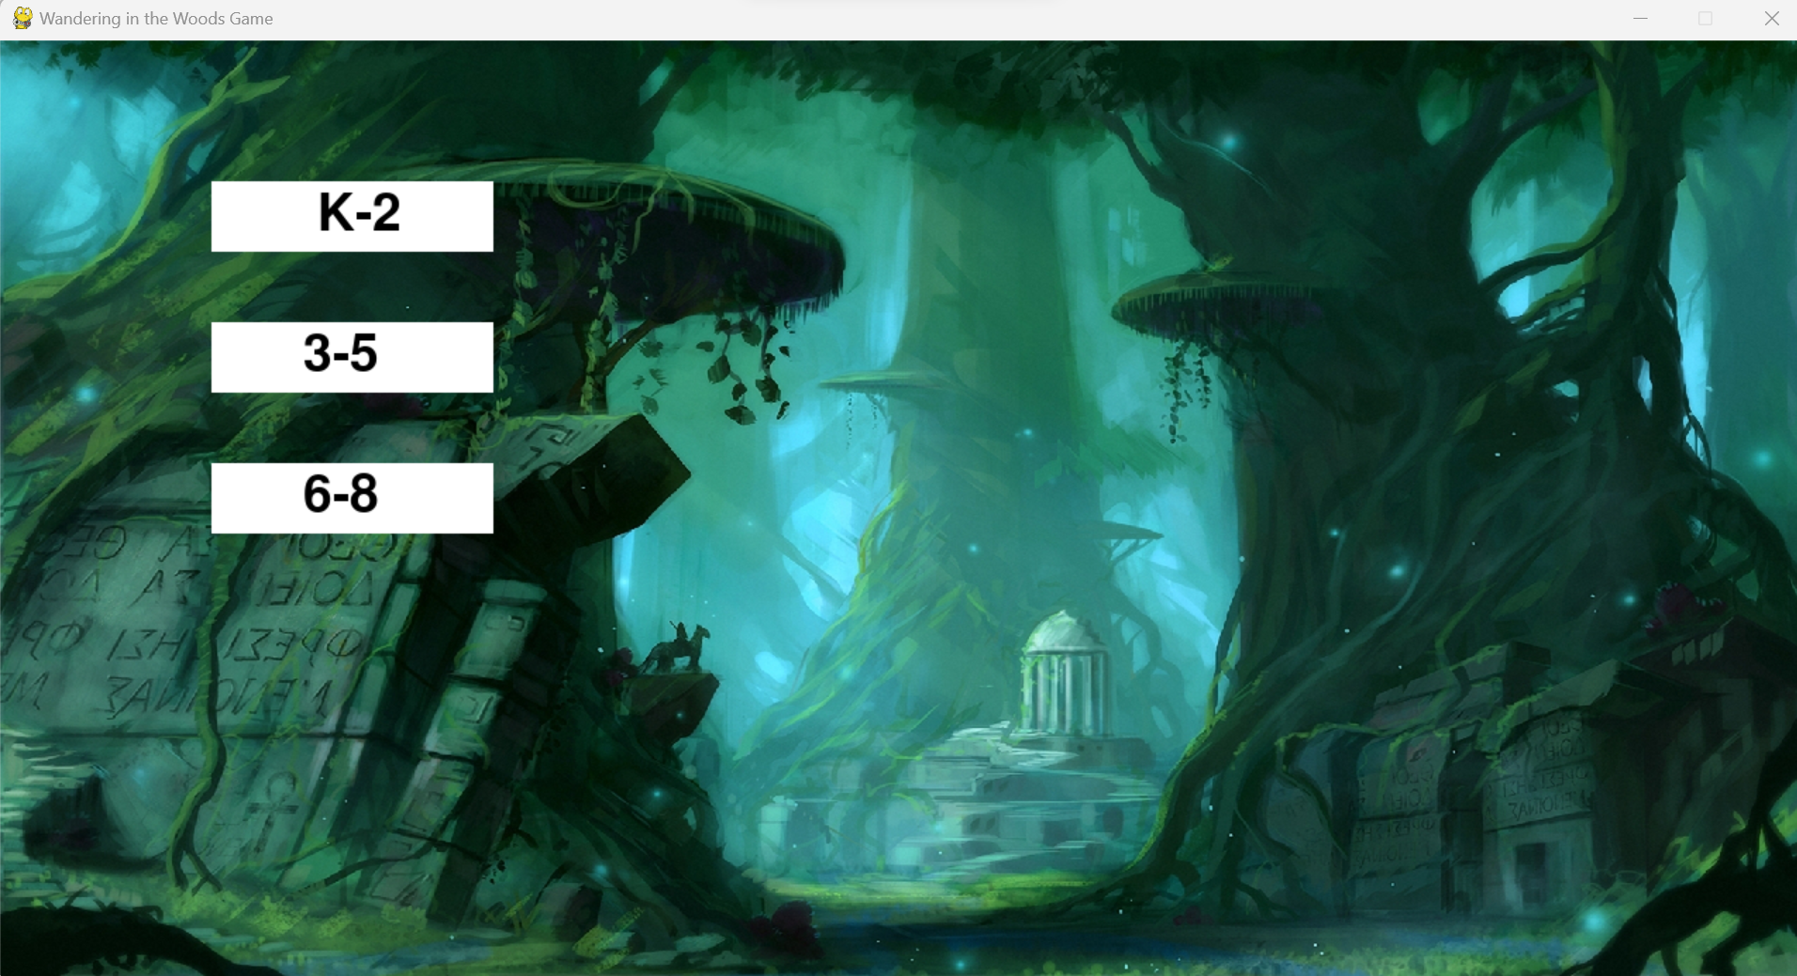

**K-2 (Kindergarten to 2nd Grade)**

Description: The K-2 game mode is intended for our youngest explorers. It has a vivid, kid-friendly setting and simple gameplay. Player’s travel across the jungle in quest of their friends.Top of Form

**3-5 (3rd to 5th Grade)**

Description: The 3-5 game mode offers a more challenging experience. Players in this mode navigate through a larger forest area and must strategize to meet their fellow adventurers.

**3 6-8 (6th to 8th Grade)**

Description: The 6-8 game mode is the most challenging of all. Players explore an expansive and complex forest, requiring careful planning and decision-making to reunite with their companions.

Choose the game mode that suits your age group and skill level and embark on your forest adventure accordingly.

**How to Play**

**Step-by-Step Instructions for Playing the Game**

Playing "Wandering in the Woods" is an exciting adventure, and here's a step-by-step guide to get you started:

1. Launch the game following the instructions provided in the "Getting Started" section of this guide.
2. Select your desired game mode: K-2, 3-5, or 6-8, based on your age group and skill level.



1. You'll find yourself in the dense forest. Your objective is to meet up with the other players in the forest.

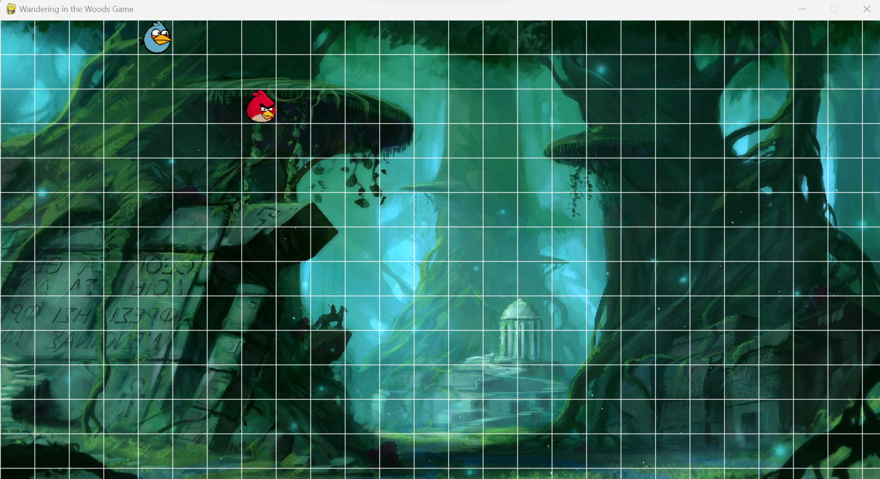

4. Use your keyboard's arrow keys to move your character in the proper directions (up, down, left, right). Explore the woodland but be aware of potential hazards.

1. As you move, try to reach the same location as the other players. When two or more players occupy the same cell in the grid, they will merge into a group.

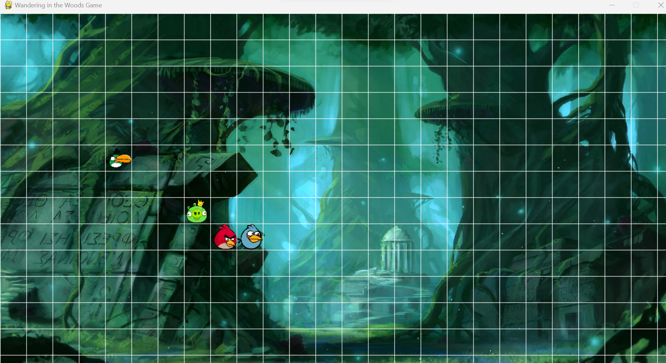

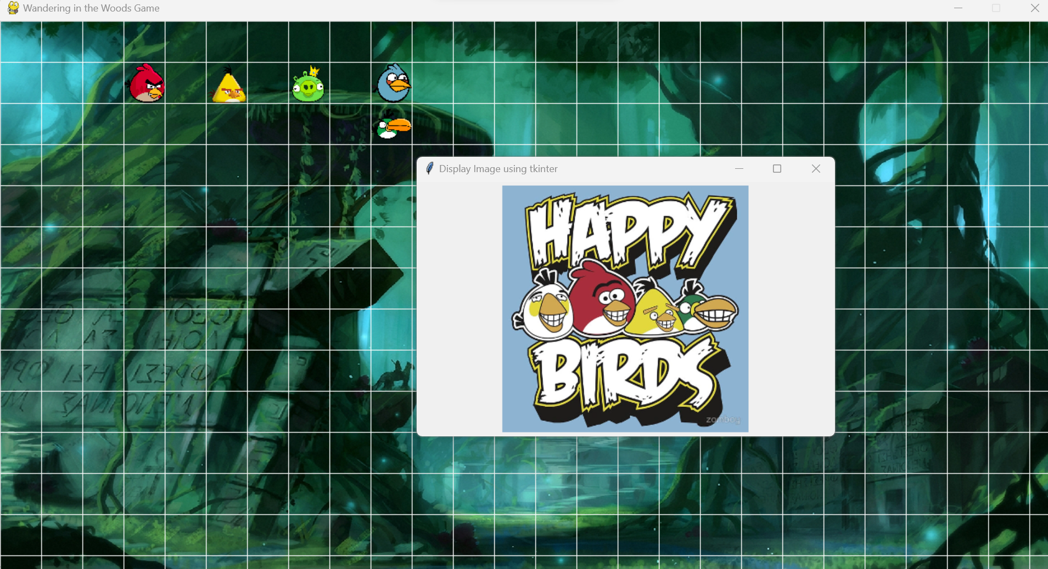

1. Keep an eye on the game statistics, which include the longest run, shortest run, and average run. These metrics track your progress as you play.

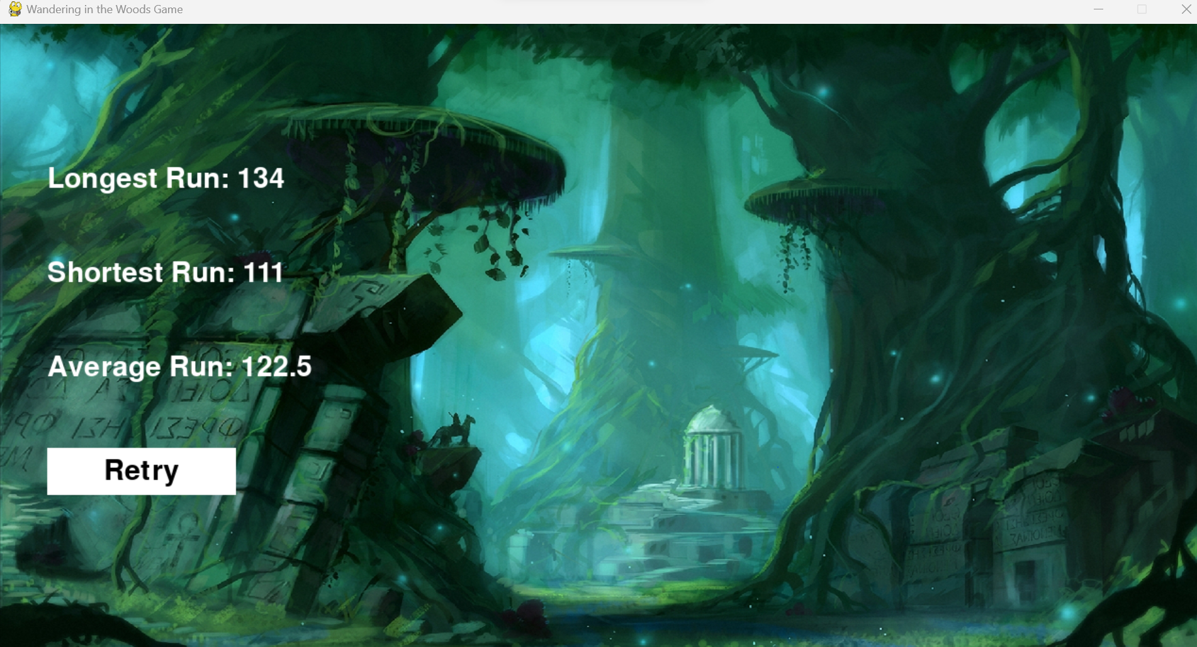

1. Enjoy the forest adventure and try to reunite with all the players. Remember that teamwork and strategy can be key to your success!

**Explanation of Game Objectives**

The primary objective of "Wandering in the Woods" is to navigate through the forest and guide all players to meet at the same location. The game encourages exploration, strategy, and teamwork. Your goal is to achieve the following:

* Explore the forest while avoiding obstacles.
* Strategize your movements to meet other players.
* Form groups by meeting up with other players in the same grid cell.
* Achieve the longest run, shortest run, and an average run to track your progress.

Now that you know how to play and understand the game's objectives, let's dive into the game mechanics and controls.

**Game Statistics**

Explanation of Game Statistics Display (Longest Run, Shortest Run, Average Run)

In "Wandering in the Woods," you can track your progress and performance through the game statistics. The game provides the following statistics:



* Longest Run: This statistic records the longest time it took for all players to meet and form a group. It's a measure of the most challenging scenario you encountered during your gameplay.
* Shortest Run: The shortest run represents the quickest meetup of all players in a game session. It showcases your ability to efficiently guide players to a common location.
* Average Run: The average run calculates the average time it took for players to meet and form groups across multiple game sessions. It gives you an idea of your overall performance.

These statistics add an extra layer of challenge and competition to the game. Try to improve your stats by strategizing and exploring more efficiently!

**Troubleshooting**

**Common Issues and Solutions**

While playing "Wandering in the Woods," you might encounter some common issues. Here are solutions to help you troubleshoot these problems:

* Issue: Game Crashes or Freezes
* Workaround: Make sure you have the Python and Pygame libraries installed on your system. Try running the game again after updating your graphics drivers.
* Issue: Sound Not Working
  + Solution: Check your system's sound settings. Make sure that the sound is enabled both in the game and on your computer. Adjust the volume settings within the game using the sound control key (usually "S").
* Issue: Controls Are Unresponsive
  + Solution: Ensure that the game window is active and in focus. Sometimes, other background applications may interfere with the game's controls. Restart the game if needed.
* Issue: Unable to Meet Other Players
  + Solution: Meeting other players requires strategic movement. Plan your route carefully and coordinate with other players if you're playing in a group. Remember that the forest is filled with obstacles, so be patient.
* Issue: Game Graphics Look Distorted
  + Solution: Check your display settings and ensure that your screen resolution is compatible with the game. Adjust your screen resolution if needed.

If you encounter an issue that is not covered here, feel free to seek assistance from our support team or online gaming communities for additional help.

Top of Form